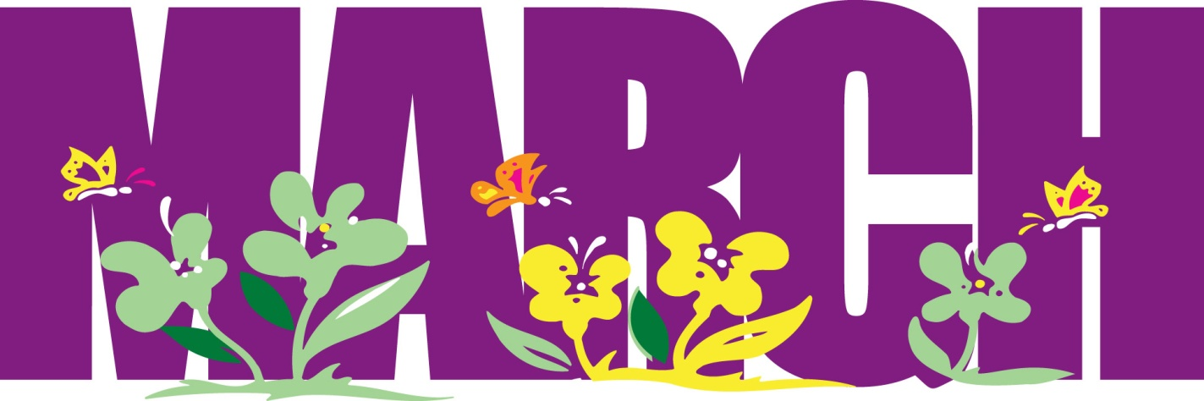
Lunch Menu – March 2023
Monday | Tuesday | Wednesday | Thursday | Friday
 |  | 1  Gyros w/ Tzatziki Sauce, Pasta Salad w/ Asiago Cheese  Fresh Fruit & vegetables  Breakfast: Breakfast Burrito / Churros | 2  Chili Mac w/ Seasoned Breadstick  Fresh Fruit and Vegetables  Breakfast: Corn Dog / Hashbrowns | 3  No School  Professional Development
6  Pizza Puffs w/ Marinara  Peas & Cherry Tomatoes  Oranges & Chilled Pears  Breakfast: Omelets /w Bacon | 7  Junior ACT Testing  Early Release – No Lunch | 8  Pepper Steak w/Fried Rice  Stir Fry Vegetable Eggroll  Melon & Chilled Peaches  Breakfast: Breakfast Burrito / Churros | 9  Sloppy Joes w/ Chips  Steamed Corn & Cucumber  Grapes & Chilled Pineapples  Breakfast: Corn Dog / Hashbrowns | 10  Fish Sandwich w/Potato Wedge  Mixed Vegetables & Fresh Broccoli  Grapes & Chilled Pineapples  Breakfast: Biscuit n Gravy/ Scrambled Egg
13  BBQ Chicken Sandwich /w Potatoes  Oranges & Chilled Pears  Breakfast: Omelets /w Bacon | 14  Sliced Turkey w/ Gravy  Stuffing & Sweet Potatoes  Melon & Chilled Peaches  Breakfast: Scrambled Eggs /Sausage | 15  Stuffed Baked Potatoes  Corn & Fresh Cauliflower  Melon & Chilled Peaches  Breakfast: Breakfast Burrito / Churros | 16  Hamburgers w/ French Fries  Steamed Corn & Cucumber  Grapes & Chilled Pineapples  Breakfast: Corn Dog / Hashbrowns | 17  Crustable or Corn Dogs  Mixed Vegetables & Fresh Broccoli  Grapes & Chilled Pineapples  Breakfast: Biscuit n Gravy/ Scrambled Egg
20  SPRING BREAK | 21  SPRING BREAK | 22  SPRING BREAK | 23  SPRING BREAK | 24  SPRING BREAK
27  Spicy Chicken Sandwich  Fresh Vegetable w/ ranch  Oranges & Chilled Pears  Breakfast: Omelets /w Bacon | 28  French Bread Pizza  Pasta Salad  Steamed Peas & Fresh Cauliflower Melon & Chilled Peaches  Breakfast: Scrambled Eggs /Sausage | 29  Ham & Cheese Sliders  Corn & Fresh Cauliflower  Jello or Chilled Peaches  Breakfast: Breakfast Burrito / Churros | 30  Meatball Subs  Steamed Corn & Cucumber  Grapes & Chilled Pineapples  Breakfast: Corn Dog / Hashbrowns | 31  Walking Nachos  Mixed Vegetables & Fresh Broccoli  Grapes & Chilled Pineapples  Breakfast: Biscuit n Gravy/ Scrambled Egg

This institution is an equal opportunity provider.

